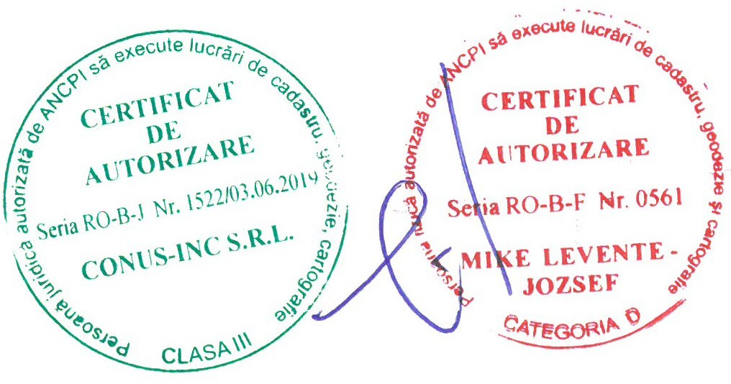
ANEXA Nr. 3

OPISUL ALFABETIC AL TITULARILOR DREPTURILOR REALE DE PROPRIETATE, AL POSESORILOR ȘI AL ALTOR DEȚINĂTORI
Județul HARGHITA UAT Dealu

Nr. crt. | Nume / denumire deţinător | Data naşterii  / CUI | Identificator | Planşa | Sector cadastral | Adresa imobilului | Suprafaţa în proprietate (mp) | Suprafaţa în posesie (mp) | Observaţii deţinător
1 | ANDRAS DOMOKOS |  | 2747 | 1 | 127 | Extravilan, Loc. Tibod, UAT. Dealu, Jud. Harghita; (Tarla: 100, Parcela: 3277/2; Tarla: 100, Parcela: 3276/2; Tarla: 100, Parcela: 3276/4; Tarla: 100, Parcela: 3278/1) | 6467 |  | Lipsa CNP, proprietar decedat.
2 | BENKE JOZSEF- DANIEL | 20.05.1981 | 2743 | 1 | 127 | Extravilan, Loc. Tibod, UAT. Dealu, Jud. Harghita; (Tarla: 100, Parcela: -) | 7155
3 | BENKE JOZSEF- DANIEL | 20.05.1981 | 2744 | 1 | 127 | Extravilan, Loc. Tibod, UAT. Dealu, Jud. Harghita; (Tarla: 100, Parcela: -) | 7156
4 | Bereczi Ladislau | 06.07.1950 | 2758 | 1 | 127 | Extravilan, UAT. Dealu, Jud. Harghita; (Tarla: 100, Parcela: -) | 3614
5 | CSENDOR EVA |  | 2761 | 1 | 127 | Extravilan, Loc. Tibod, UAT. Dealu, Jud. Harghita; (Tarla: 100, Parcela: -) | 1422 |  | Lipsa CNP
6 | CSENDOR IOAN |  | 2761 | 1 | 127 | Extravilan, Loc. Tibod, UAT. Dealu, Jud. Harghita; (Tarla: 100, Parcela: -) | 1422 |  | Lipsa CNP
7 | CSIKI ANA | 05.07.1930 | 2760 | 1 | 127 | Extravilan, Loc. Tibod, UAT. Dealu, Jud. Harghita; (Tarla: 100, Parcela: 3276/6; Tarla: 100, Parcela: 3279/1; Tarla: 100, Parcela: 3276/5) | 3736 |  | Proprietar decedat.
8 | FÜLÖP LUDOVIC |  | 2751 | 1 | 127 | Extravilan, Loc. Tibod, UAT. Dealu, Jud. Harghita; (Tarla: 100, Parcela: 13-466) | 3369 |  | Lipsa CNP.
9 | FÜLÖP SÁNDOR |  | 2751 | 1 | 127 | Extravilan, Loc. Tibod, UAT. Dealu, Jud. Harghita; (Tarla: 100, Parcela: 13-466) | 3369 |  | Lipsa CNP.
10 | KEDVES ERZSÉBET |  | 2751 | 1 | 127 | Extravilan, Loc. Tibod, UAT. Dealu, Jud. Harghita; (Tarla: 100, Parcela: 13-466) | 3369 |  | Lipsa CNP.
11 | KOCS AGNES |  | 2753 | 1 | 127 | Extravilan, Loc. Tibod, UAT. Dealu, Jud. Harghita; (Tarla: 100, Parcela: -) | 9598 |  | Lipsa CNP,
12 | KOCS AGNES |  | 2755 | 1 | 127 | Extravilan, Loc. Tibod, UAT. Dealu, Jud. Harghita; (Tarla: 100, Parcela: -) | 468 |  | Lipsa CNP,
13 | KOCS AGNES | 17.04.1976 | 2756 | 1 | 127 | Extravilan, UAT. Dealu, Jud. Harghita; (Tarla: 100, Parcela: 13-471; Tarla:  100, Parcela: 13-472) | 2935
 |  |  | 2757 | 1 | 127 | Extravilan, UAT. Dealu, Jud. Harghita; (Tarla: 100, Parcela: -) | 7875
14 | KOCS ZOLTAN |  | 2753 | 1 | 127 | Extravilan, Loc. Tibod, UAT. Dealu, Jud. Harghita; (Tarla: 100, Parcela: -) | 9598 |  | Lipsa CNP
 |  |  | 2755 | 1 | 127 | Extravilan, Loc. Tibod, UAT. Dealu, Jud. Harghita; (Tarla: 100, Parcela: -) | 468
15 | KOCS ZOLTAN | 24.10.1974 | 2756 | 1 | 127 | Extravilan, UAT. Dealu, Jud. Harghita; (Tarla: 100, Parcela: 13-471; Tarla:  100, Parcela: 13-472) | 2935
16 | KOCS ZOLTAN | 24.10.1974 | 2757 | 1 | 127 | Extravilan, UAT. Dealu, Jud. Harghita; (Tarla: 100, Parcela: -) | 7875
17 | LASZLO CSILLA |  | 2754 | 1 | 127 | Extravilan, Loc. Tibod, UAT. Dealu, Jud. Harghita; (Tarla: 100, Parcela: -) | 1000 |  | Lipsa CNP
18 | LASZLO ERNO |  | 2754 | 1 | 127 | Extravilan, Loc. Tibod, UAT. Dealu, Jud. Harghita; (Tarla: 100, Parcela: -) | 1000 |  | Lipsa CNP,
19 | NAGY ELEK |  | 2750 | 1 | 127 | Extravilan, Loc. Tibod, UAT. Dealu, Jud. Harghita; (Tarla: 100, Parcela: 13-464/1; Tarla: 100, Parcela:  13-464/2; Tarla: 100, Parcela: 13-465) | 3752 |  | Lipsa CNP.
20 | NAGY GÁBOR |  | 2750 | 1 | 127 | Extravilan, Loc. Tibod, UAT. Dealu, Jud. Harghita; (Tarla: 100, Parcela: 13-464/1; Tarla: 100, Parcela:  13-464/2; Tarla: 100, Parcela: 13-465) | 3752 |  | Lipsa CNP.

Nr. crt. | Nume / denumire deţinător | Data naşterii  / CUI | Identificator | Planşa | Sector cadastral | Adresa imobilului | Suprafaţa în proprietate (mp) | Suprafaţa în posesie (mp) | Observaţii deţinător
21 | NAGY GÁSPÁR |  | 2750 | 1 | 127 | Extravilan, Loc. Tibod, UAT. Dealu, Jud. Harghita; (Tarla: 100, Parcela: 13-464/1; Tarla: 100, Parcela:  13-464/2; Tarla: 100, Parcela: 13-465) | 3752 |  | Lipsa CNP.
22 | NAGY VERONIKA |  | 2750 | 1 | 127 | Extravilan, Loc. Tibod, UAT. Dealu, Jud. Harghita; (Tarla: 100, Parcela: 13-464/1; Tarla: 100, Parcela:  13-464/2; Tarla: 100, Parcela: 13-465) | 3752 |  | Lipsa CNP.
23 | NAGY VILMA |  | 2748 | 1 | 127 | Extravilan, Loc. Tibod, UAT. Dealu, Jud. Harghita; (Tarla: 100, Parcela: 13-463/1; Tarla: 100, Parcela:  13-463/2; Tarla: 100, Parcela: 13-462) | 6620 |  | Lipsa CNP
24 | NYISZTOR ZENOBIA |  | 2751 | 1 | 127 | Extravilan, Loc. Tibod, UAT. Dealu, Jud. Harghita; (Tarla: 100, Parcela: 13-466) | 3369 |  | Lipsa CNP.
25 | PAL IULIANA | 26.12.1931 | 2760 | 1 | 127 | Extravilan, Loc. Tibod, UAT. Dealu, Jud. Harghita; (Tarla: 100, Parcela: 3276/6; Tarla: 100, Parcela: 3279/1; Tarla: 100, Parcela: 3276/5) | 3736 |  | Proprietar decedat.
26 | PAL JOZSEF |  | 2746 | 1 | 127 | Extravilan, Loc. Tibod, UAT. Dealu, Jud. Harghita; (Tarla: 100, Parcela: 3277/1; Tarla: 100, Parcela: 3276/1; Tarla: 100, Parcela: 3276/3) | 6242 |  | Lipsa CNP, proprietar decedat.
27 | PÁL KÁROLY |  | 2745 | 1 | 127 | Extravilan, Loc. Tibod, UAT. Dealu, Jud. Harghita; (Tarla: 100, Parcela: 13-456; Tarla: 100, Parcela: 13-455) | 4997 |  | Lipsa CNP.
28 | PÁL LÁSZLÓ |  | 2745 | 1 | 127 | Extravilan, Loc. Tibod, UAT. Dealu, Jud. Harghita; (Tarla: 100, Parcela: 13-456; Tarla: 100, Parcela: 13-455) | 4997 |  | Lipsa CNP.
29 | PÁLL IOAN |  | 2762 | 1 | 127 | Extravilan, Loc. Tibod, UAT. Dealu, Jud. Harghita; (Tarla: 100, Parcela: 13-484/1; Tarla: 100, Parcela:  13-484/2) | 6670 |  | Lipsa CNP
30 | Sandor Attila | 07.01.1978 | 2759 | 1 | 127 | Extravilan, UAT. Dealu, Jud. Harghita; (Tarla: 100, Parcela: -) | 2711
31 | SZOKE DOMINIC | 25.03.1929 | 2760 | 1 | 127 | Extravilan, Loc. Tibod, UAT. Dealu, Jud. Harghita; (Tarla: 100, Parcela: 3276/6; Tarla: 100, Parcela: 3279/1; Tarla: 100, Parcela: 3276/5) | 3736 |  | Proprietar decedat.
32 | SZOKE EMERIC | 07.10.1937 | 2760 | 1 | 127 | Extravilan, Loc. Tibod, UAT. Dealu, Jud. Harghita; (Tarla: 100, Parcela: 3276/6; Tarla: 100, Parcela: 3279/1; Tarla: 100, Parcela: 3276/5) | 3736 |  | Proprietar decedat.
33 | SZOKE LUDOVIC | 16.08.1927 | 2760 | 1 | 127 | Extravilan, Loc. Tibod, UAT. Dealu, Jud. Harghita; (Tarla: 100, Parcela: 3276/6; Tarla: 100, Parcela: 3279/1; Tarla: 100, Parcela: 3276/5) | 3736 |  | Proprietar decedat.
34 | SZOKE MARTON- ARPAD | 06.05.1926 | 2760 | 1 | 127 | Extravilan, Loc. Tibod, UAT. Dealu, Jud. Harghita; (Tarla: 100, Parcela: 3276/6; Tarla: 100, Parcela: 3279/1; Tarla: 100, Parcela: 3276/5) | 3736 |  | Proprietar decedat.
35 | SZOKE VASILE | 18.09.1934 | 2760 | 1 | 127 | Extravilan, Loc. Tibod, UAT. Dealu, Jud. Harghita; (Tarla: 100, Parcela: 3276/6; Tarla: 100, Parcela: 3279/1; Tarla: 100, Parcela: 3276/5) | 3736 |  | Proprietar decedat.
36 | UAT DEALU | 999999999-  9999 | 2749 | 1 | 127 | Extravilan, Loc. Tibod, UAT. Dealu, Jud. Harghita; (Tarla: 100, Parcela: -) | 1932 |  | Proprietar neidentificat
 |  |  | 2752 | 1 | 127 | Extravilan, Loc. Tibod, UAT. Dealu, Jud. Harghita; (Tarla: 100, Parcela: 13-467) | 393

